(Approx. 1020 words)

Rescuezilla – A Flexible Backup Solution
By Alan German, Treasurer
Ottawa PC Users' Group, Ontario, Canada
https://opcug.ca
Published in Ottawa PC News (May 2023)
Editor: brigittelord (at) opcug.ca

For several years, my disk imaging backup program of choice has been Macrium Reflect Free Edition; however, recently, Macrium's developers announced that the free version is to be discontinued. Security updates will be provided until January 1, 2024, after which, although the program can still be used, no new features or support will be provided. Consequently, this seems to be a good time to seek out an alternative backup solution for the long term.

The other aspect of this issue is my growing preference for Linux over Windows, especially given that none of my computers will support Windows 11, and the end-of-life date for Windows 10 is October 2025. However, my previous experiences with disk imaging programs for Linux have found these lacking the flexibility and ease of use offered by their Windows counterparts.

For example, Clonezilla has an old-style, text-based interface that is somewhat complex and difficult to navigate. The program can create a backup using either its save disk or saveparts feature. Savedisk allows the entire disk to be restored but will not restore single partitions. In contrast, save parts will restore one or more partitions but will not restore the master boot record or the partition table and so can't be use to restore the entire disk. Clearly, this is not very helpful when it comes to flexibility in restoring disks and/or partitions.

But now, there is a new kid on the block – Rescuezilla – that offers a user-friendly, graphical user interface, clearly-defined icons and menus for specific tasks, and the flexibility to save and restore both disks and partitions.

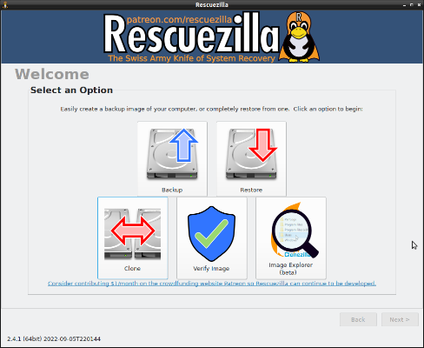

Rescuezilla can be downloaded as an ISO file (the current version is rescuezilla-2.4.1-64bit.jammy.iso) that can be used to create a bootable USB flash drive. As the "jammy" portion of the file name indicates, the USB boots into a version of Ubuntu Linux; however, this operating system is initially hidden from the end user as Rescuezilla loads in full-screen mode.

The main menu provides Backup and Restore options, in addition to icons for Clone, Verify Image, and Image Explorer. The latter option is a work in progress and is intended to allow mounting a disk partition directly from the backup image in order to extract individual files and folders. However, for our present purposes we will just consider the main two options for Backup and Restore.

Selecting Backup launches a wizard that steps through the required process. Firstly, the source drive that is to be backed up is selected from a menu of available disks. Back and Next buttons on the individual screens allow easy navigation. The subsequent screen, Step 2: Select Partitions to Save, allows selection of the partitions that are to be included in the backup. Windows users should note that since we are using a Linux system, no drive letters are used. Rather, the partitions are listed with drive and partition numbers, the size of the drive, the file system, and any partition label.

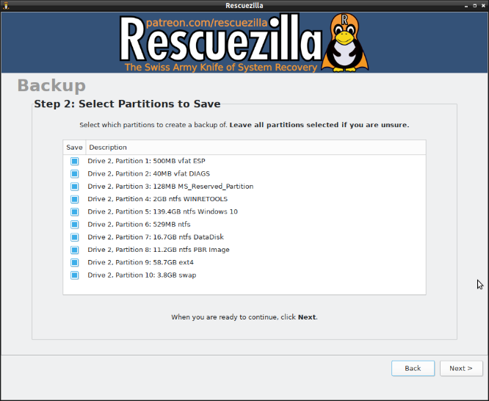

If not all the partitions are to be backed up (or restored), it's clearly important to be able to identify the desired partition using the information that is displayed. For example, the screenshot shows the partitions for a disk that dual boots Windows 10 and Linux. The Windows partition (Drive C:), Partition 5, is labeled as Windows 10, while the Linux partition, Partition 9, is using the ext4 file system.

By default, all of the available partitions are checked and so, to make a full disk image backup, we just have to press the Next button. The subsequent screen allows selection of the destination drive on which the disk image is to be stored. This is followed by a similar screen that selects a folder on the destination drive as the storage location. Once again, a Linux protocol specifies a mount point as /mnt/backup. This can be refined by using the Browse button to point to a specific folder on the destination drive, e.g.,/mnt/backup/z_images/Rescuezilla.

The next screen provides a default name for the backup image (e.g., 2023-01-21-2004-img-rescuezilla), allows this name to be customized, and displays an option to include descriptive text. This is followed by a screen on which the compression algorithm and level can be specified. These can readily be left at their default settings of gzip and 6, respectively.

The final screen provides a summary of settings selected, including the source drive and the partitions to be backed up. Clicking on Next starts the backup process, which then runs unattended.

The resulting image takes the form of a folder with multiple files that are clearly a mix of administrative information and segments of compressed partitions (e.g., sda5.ntfs-ptcl-img.gz.aa, …gz.ab, …gz.ac). In my baseline test, the overall file compression was approximately 60%.
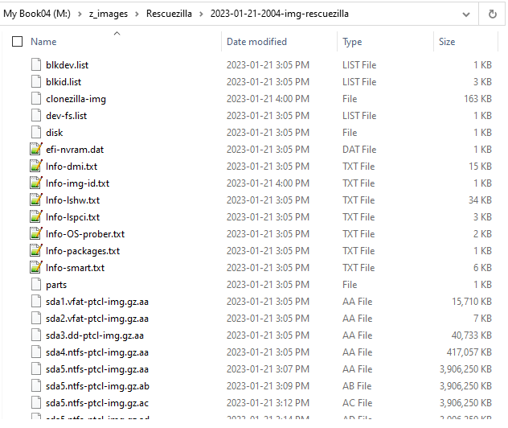

Restoring from a backup image is essentially the reverse of the backup process. The image file on the backup disk is identified; the partition(s) to be restored and the disk on which the partition(s) is to be restored are selected. I tried a number of restorations, including just my dedicated data drive, which I could verify against a file-by-file backup stored on a USB flash drive. I also restored the Linux operating system partition and swap area (Partitions 9 and 10), and the entire drive. In each of the latter cases, success was confirmed by the fact that the disk subsequently booted normally into both Linux and Windows via the GRUB boot menu.

For me, these tests have confirmed that Rescuezilla is a viable backup-restore solution for my system. For Linux users, the processes and nomenclature will be straightforward. Windows users will perhaps need to pay attention to the listings of disks, partitions, and folders, as the designations (e.g., mount points) are quite different between Linux and Windows. However, that being said, the fact that Rescuezilla functions as a live-USB provides a ready-made backup option for both operating systems and can be used even if the PC refuses to boot normally from the hard drive.

Bottom Line

Rescuezilla (Open source)

Version 2.4.1

https://rescuezilla.com

